**Results report**

*Clarissa, 09-08-23*

Selection of studies

Figure 1 shows the PRISMA flowchart for our study. Both screening stages were conducted by a single reviewer. Agreement levels in the first screening stage are available at <https://osf.io/bg4qt>.

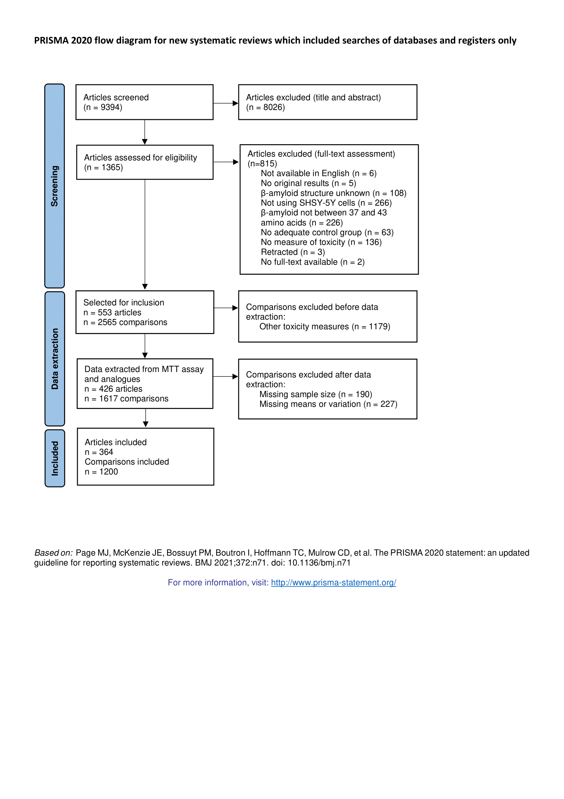

Figure 1 – PRISMA Flowchart

Although our search and inclusion criteria selected for any kind of toxicity measure, due to large sample sizes (Table 1) we opted to extract data only for those classified as MTT assay and analogues.

Table 1 - Toxicity assays identified.

| **Method** | **n** |
| --- | --- |
| MTT and analogues reduction | 1386 |
| LDH release | 200 |
| Trypam blue exclusion test | 74 |
| Other cell viability assays | 184 |
| Direct indicators of cell death | 86 |
| Direct indicators of apoptosis | 296 |
| Other markers of cell death | 69 |
| Reactive oxygen species | 141 |
| Damage to mitochondrial membrane | 54 |
| Products of oxidative stress | 52 |
| Other oxidative stress assays | 19 |
| Unclear/Not recorded | 4 |

Sample description

Included articles were published between 1998 and 2021 (Figure 2).

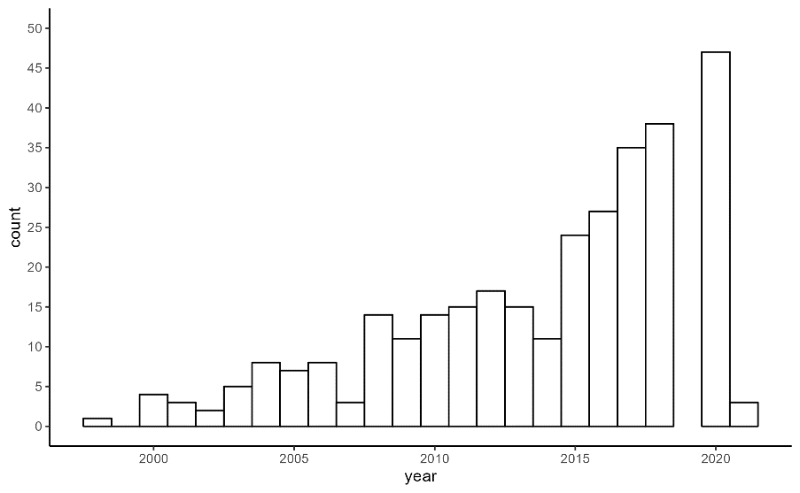

Figure 2 – Histogram of year of online publication.

Table 2 summarizes the reporting of article-level variables. Notably, most studies assessed used the SHSY-5Y cell line with Aβ as a model to test an intervention aimed at reversing toxic effects (70%). None of the 364 studies extracted reported a sample size calculation for any of the included experiments.

Table 3 - Article-level reporting. % is in relation to 364 included articles.

| **Feature** | **N** | **%** |
| --- | --- | --- |
| Studies testing reversal | 254 | 69.8 |
| Provides sample size calculation | 0 | 0.0 |
| Includes conflict of interest statement | 185 | 50.8 |
| Has pre-registered | 10 | 2.7 |

Articles included between 1 and 52 comparisons each, with a median of 2 comparisons per article (Figure 3).

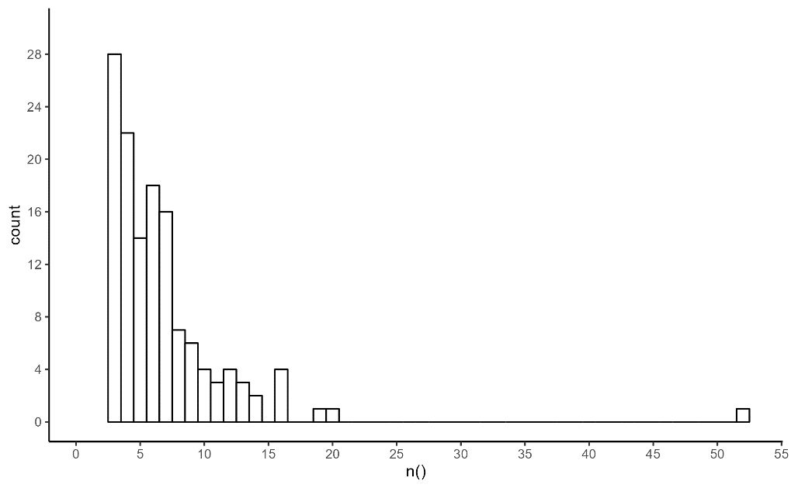

Figure 3 – Number of comparisons per article.

Table 3 summarizes the assays used in the included articles. MTT was the most predominant assay, both in terms of number of comparisons as well as number of articles. No article included experiments using different assays.

Table 3 – Comparison-level reporting. For comparisons, % is in relation to 1200 included comparisons; for articles, % is in relation to 364 included articles.

|  |  |  |  |  |  |
| --- | --- | --- | --- | --- | --- |
| **Protocol variable** | **Value** | **Comparisons** | | **Articles** | |
| **N** | **%** | **N** | **%** |
| Assay | MTT | 1012 | 84.3 | 304 | 83.5 |
| WST | 81 | 6.8 | 23 | 6.3 |
| CCK-8 | 51 | 4.2 | 12 | 3.3 |
| MTS | 32 | 2.7 | 17 | 4.7 |
| XTT | 15 | 1.2 | 5 | 1.4 |
| Resazurin | 7 | 0.6 | 1 | 0.3 |
| EZ4U | 2 | 0.2 | 2 | 0.5 |

Table 4 summarizes the reported quality measures of the cell cultures used. Regarding origin, most originate from cell banks, mainly the American Type Culture Collection (ATCC) and the European Collection of Authenticated Cell Cultures (EACC) (see Table 5). However, a large proportion of experiments use cells from unknown origin. Only 17 experiments (from 2 articles) report authenticating the cell lines and 18 (from 3 articles) report testing for mycoplasma contamination, but none of them provide the protocols used for these tests.

Table 4 - Cell line quality control. For comparisons, % is in relation to 1200 included comparisons; for articles, % is in relation to 364 included articles.

|  |  |  |  |  |  |
| --- | --- | --- | --- | --- | --- |
| **Protocol variable** | **Category** | **Comparisons** | | **Articles** | |
| **N** | **%** | **N** | **%** |
| Cell source | Cell banks | 648 | 54.0 | 183 | 50.3 |
| Donation | 82 | 6.8 | 17 | 4.7 |
| Unclear/Not reported | 470 | 39.2 | 164 | 45.1 |
| Cell line authentication | Yes, with protocol | 0 | 0 | 0 | 0 |
| Yes, no protocol | 17 | 1.4 | 2 | 0.5 |
| No/Not reported | 1183 | 98.6 | 363 | 99.8 |
| Cell line mycoplasma testing | Yes, with protocol | 0 | 0 | 0 | 0 |
| Yes, no protocol | 18 | 1.5 | 3 | 0.8 |
| No/Not reported | 1182 | 98.5 | 361 | 99.2 |

Table 5 – List of cell banks. N is the number of articles. % is in relation to 364 included articles.

| **Cell bank** | **N** | **%** |
| --- | --- | --- |
| American Type Culture Collection (ATCC) | 110 | 30.2 |
| European Collection of Authenticated Cell Cultures (ECACC) | 30 | 8.2 |
| Chinese Academy of Sciences | 15 | 4.1 |
| Leibniz Institute DSMZ - German Collection of Microorganisms and Cell Cultures GmbH | 7 | 1.9 |
| National Centre for Cell Science (NCCS) | 5 | 1.4 |
| Korean Cell Line Bank | 3 | 0.8 |
| Riken Cell Bank | 3 | 0.8 |
| Pasteur Institute of Iran | 2 | 0.5 |
| Sigma-Aldrich | 2 | 0.5 |
| Institute of Biochemistry and Cell Biology | 1 | 0.3 |
| Invitrogen | 1 | 0.3 |
| LGC Promo-chem | 1 | 0.3 |
| The Cell Resource Centre of Institute of Basic Medicine | 1 | 0.3 |
| Zhong Qiao Xin Zhou Biotec Co., Ltd | 1 | 0.3 |
| Not reported | 1 | 0.3 |

Table 6 summarizes the protocol variables for cell culture. The most prevalent culture medium used is a combination of DMEM and F12, with the use of DMEM alone following closely. Around 9% of comparisons do not describe the culture medium used. Most experiments include antibiotics in the culture medium, and around 40% of the experiments include glutamine supplementation. Most experiments include 10% of FBS in the cell culture protocol, but a great variation of serum types and concentrations could also be found (Table 7).

Table 6 – Cell culture protocol. % is in relation to 1200 included comparisons

|  |  |  |  |
| --- | --- | --- | --- |
| **Protocol variable** | **Category** | **Comparisons** | |
| **N** | **%** |
| Culture medium | DMEM_F12 | 439 | 36.6 |
| DMEM | 376 | 31.3 |
| MEM_F12 | 119 | 9.9 |
| MEM | 60 | 5.0 |
| RPMI | 47 | 3.9 |
| F12 | 24 | 2.0 |
| EMEM_F12 | 21 | 1.8 |
| EMEM | 8 | 0.7 |
| OptiMEM | 3 | 0.2 |
| Not reported | 103 | 8.6 |
| Antibiotics | Yes | 863 | 71.9 |
| No/Not reported | 337 | 28.1 |
| Glutamine | Yes | 472 | 39.3 |
| No/Not reported | 728 | 60.7 |

Table 7 - Cell serum type and concentration.

| **Serum type** | **Serum concentration** | **n** |
| --- | --- | --- |
| FBS | 10% | 688 |
| Not reported | Not reported | 183 |
| FCS | 15% | 146 |
| FCS | 10% | 78 |
| FBS | 15% | 59 |
| FBS | 18% | 7 |
| FBS | 17% | 6 |
| FCS | 5% | 6 |
| FBS | Unclear/Not reported | 7 |
| FBS | 2% | 3 |
| FBS and HS | 5% of each | 3 |
| CS | 10% | 2 |
| FBS | 20% | 2 |
| FCS | 20% | 2 |
| NO SERUM | - | 2 |
| FBS | 5% | 1 |
| FBS | 12% | 1 |
| FCS | 2% | 1 |
| FCS | Unclear/Not reported | 1 |
| FCS and FHS | 10% and 5%, respectively | 1 |
| FCS and HS | 5% and 10%, respectively | 1 |

Table 8 summarizes the treatment protocol variables. The most prevalent sequence of the Aβ peptide was 42 amino acids long (in 80% of included experiments), but most of the experiments did not describe either the origin of the peptide or if the sequence was based on humans or other animals. Almost half of the experiments did not have a clear aggregation description, likely representing mixtures of different aggregate sizes. Of the ones described, most of them were oligomeric forms. The description of which control condition was used was also unclear for almost half of the experiments.

Table 8 – Treatment protocol variables.

|  |  |  |  |
| --- | --- | --- | --- |
| **Protocol variable** | **Category** | **Comparisons** | |
| **N** | **%** |
| Aβ sequence | 1-42 | 963 | 80.2 |
| 1-40 | 217 | 18.1 |
| 1-43 | 10 | 0.8 |
| 1-38 | 2 | 0.2 |
| Unclear/Not reported | 8 | 0.7 |
| Aβ origin | Synthetic | 524 | 43.7 |
| Recombinant | 52 | 4.3 |
| Unclear/Not reported | 624 | 52.0 |
| Aβ species | Human | 232 | 19.3 |
| Rat | 5 | 0.4 |
| Unclear/Not reported | 963 | 80.2 |
| Aβ aggregation | Oligomers | 462 | 38.5 |
| Fibers | 107 | 8.9 |
| Monomers | 92 | 7.7 |
| Unclear/Not reported | 539 | 44.9 |
| Control description | Vehicle | 345 | 28.7 |
| Medium only | 290 | 24.2 |
| Other | 41 | 3.4 |
| Unclear/Not reported | 524 | 43.7 |

All but one experiment clearly described a single exposure to Aβ. Table 9 summarizes the treatment duration and concentration used in the included experiments. For 12 and 17 experiments, the paper did not report the duration of Aβ exposure and the Aβ concentration used, respectively. Among those reported, a very large range of values can be observed.

Table 9 – Treatment quantitative variables.

| **Protocol variable** | **Estimate** | **Data** |
| --- | --- | --- |
| Duration of exposure, in hours | n | 1188 |
| mean | 33.1 |
| sd | 16.8 |
| median | 24 |
| min | 0 |
| max | 144 |
| Concentration, in uM | n | 1183 |
| mean | 41.3 |
| sd | 872.4 |
| median | 8 |
| min | 0 |
| max | 30000 |

Only 22.6% (n=272) of the experiments used differentiated cells. Table 10 summarizes the differentiation protocols used. Overall, culture medium was less well described for the differentiation protocols than for general cell culture but the same two types of medium (DMEM and DMEM+F12) were also the most used in these protocols.

Table 10 – Differentiation protocol variables. % is in relation to 272 experiments with differentiated cells.

|  |  |  |  |
| --- | --- | --- | --- |
| **Protocol variable** | **Category** | **Comparisons** | |
| **N** | **%** |
| Method | ATRA | 141 | 51.8 |
| ATRA plus | 80 | 29.4 |
| Other | 25 | 9.2 |
| Unclear | 26 | 9.6 |
| Serum type | Unclear | 129 |  |
| FBS | 121 |  |
| No serum | 15 |  |
| FCS | 7 |  |
| Serum concentration | 10% | 42 |  |
| 1% | 29 |  |
| 2% | 18 |  |
| 0 | 15 |  |
| 5% | 9 |  |
| 3% | 8 |  |
| 0.1 | 7 |  |
| 2.5% | 6 |  |
| 0.5% | 5 |  |
| 0.01 | 3 |  |
| 0.02 | 1 |  |
| Medium | DMEM_F12 | 111 | 40.8 |
| DMEM | 39 | 14.3 |
| MEM | 7 | 2.6 |
| MEM_Neurobasal | 6 | 2.2 |
| N2 | 5 | 1.8 |
| Neurobasal | 4 | 1.5 |
| MEM_F12 | 3 | 1.1 |
| RPMI | 1 | 0.4 |
| Unclear | 96 | 35.3 |
| Antibiotics | Yes | 66 | 24.3 |
| No/Not reported | 185 | 68.0 |
| Glutamine | Yes | 38 | 14.0 |
| No/Not reported | 213 | 78.3 |

Table 11 summarizes the differentiation duration and concentration of retinoic acid (RA) used in the included experiments. Almost 20% of the comparisons with differentiated cells did not report either information.

Table 11 - Differentiation quantitative variables

| **Protocol variable** | **Estimate** | **Data** |
| --- | --- | --- |
| Duration of differentiation, in days | n | 224 |
| mean | 6.6 |
| sd | 3.2 |
| median | 6 |
| min | 1 |
| max | 14 |
| Concentration of RA, in µM | n | 220 |
| mean | 9.2 |
| sd | 3.4 |
| median | 10 |
| min | 0 |
| max | 20 |

Table 12 summarizes the information presented above in terms of reporting quality. Critical information is missing for a large proportion of experiments.

Table 12 - Quality of reporting

| **Feature** | **Count** | **Percent** |
| --- | --- | --- |
| Describes cell source | 730 | 60.8 |
| Describes cell authentication | 17 | 1.4 |
| Describes mycoplasma testing | 18 | 1.5 |
| Control group is clear | 676 | 56.3 |
| Describes Abeta sequence | 1192 | 99.3 |
| Describes Abeta origin | 576 | 48.0 |
| Describes Abeta species | 237 | 19.8 |
| Describes Abeta aggregation | 661 | 55.1 |
| Has single exposure | 1199 | 99.9 |
| Describes duration of Abeta exposure | 1188 | 99.0 |
| Describes concentration of Abeta | 1183 | 98.6 |

Main meta-analyses

We initially ran random-effects meta-analysis, including all 1,200 comparisons. The model yielded an effect size (Hedge’s g, [95% C.I.]) of -4.65 [-4.9, -4.4] with a p-value of <0.0001. It presented high heterogeneity: I2 = 91.8% indicates a high heterogeneity of effect sizes among the included experiments, and the Q-test p-value <0.0001 indicates that the observed differences in effect sizes between experiments would be unlikely to occur by sampling variability alone.

Given the observation of extreme outliers, we ran additional sensitivity analysis excluding outliers at different thresholds (Table 13). Given the large number of comparisons, a forest plot of any of these datasets cannot be displayed properly.

Table 13 - Sensitivity analysis (excluding outliers).

|  |  |  |  |  |  |
| --- | --- | --- | --- | --- | --- |
| **Dataset** | **Sample size** | **Effect size**  **[95% C.I.]** | **Meta-analysis p-value** | **I2** | **Q-test p-value** |
| Complete | 1200 | -4.65  [-4.9, -4.4] | <0.0001 | 91.8% | <0.0001 |
| >-900 | 1199 | -4.65  [-4.9, -4.4] | <0.0001 | 91.8% | <0.0001 |
| >-100 | 1198 | -4.64  [-4.9, -4.4] | <0.0001 | 91.8% | <0.0001 |
| >-50 | 1189 | -4.59  [-4.8, -4.4] | <0.0001 | 91.7% | <0.0001 |
| >-20 | 1129 | -4.18  [-4.4, -4.0] | <0.0001 | 90.1% | <0.0001 |
| >-10 | 955 | -3.16  [-3.3, -3.0] | <0.0001 | 85.0% | <0.0001 |

Publication Bias

For publication bias analyses, the dataset used excluded the experiment with an effect size smaller than -900. Publication bias was assessed by funnel plot asymmetry (Figure 4) and Egger’s regression test (p=0.013). Interpretation of these results is not clear, given the biological impossibility of results in the opposite direction of the ones observes (i.e., with Aβ leading to an increase in cell viability).

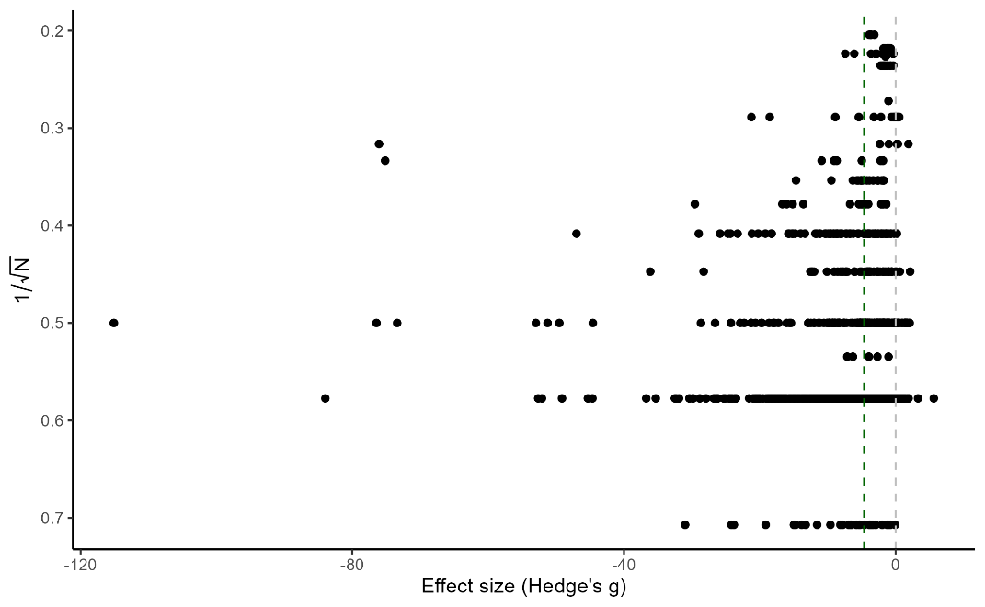

Figure 4 – Funnel plot.

3-level meta-analyses

Given the nested structure of the data, with multiple comparisons per paper, we conducted 3-level meta-analyses on the same datasets as above (Table 14). We can observe that the meta-analytical estimate is larger than the 2-level analysis, and that the heterogeneity between articles is larger than the heterogeneity between experiments from each article. The difference reduces, however, when effects smaller than -20 or -10 are excluded.

Table 14 – Summary of 3-level meta-analyses.

|  |  |  |  |  |  |  |  |  |  |
| --- | --- | --- | --- | --- | --- | --- | --- | --- | --- |
| **Dataset** | **Sample size** | | **Effect size (% freezing) [95% CI]** |  | | **Variance**  **[95% CI]** | | **I2** | |
| **Exp.** | **Art.** | **p-value** | **Between experiments** | | **Between articles** | **Exp.** | **Article** |
| Complete | 1200 | 364 | -5.28  [-5.6, -4.9] | <0.0001 | 5.43  [4.6, 6.4] | | 7.32  [5.6, 9.5] | 39.2 | 52.9 |
| >-900 | 1199 | 363 | -5.28  [-5.6, -4.9] | <0.0001 | 5.43  [4.6, 6.4] | | 7.32  [5.6, 9.5] | 39.2 | 52.9 |
| >-100 | 1198 | 363 | -5.28  [-5.6, -4.9] | <0.0001 | 5.42  [4.6, 6.4] | | 7.31  [5.6, 9.5] | 39.2 | 52.9 |
| >-50 | 1189 | 362 | -5.22  [-5.6, -4.9] | <0.0001 | 5.28  [4.5, 6.2] | | 7.02  [5.4, 9.1] | 39.5 | 52.5 |
| >-20 | 1129 | 353 | -4.74  [-5.0, -4.4] | <0.0001 | 4.38  [3.7, 5.2] | | 4.78  [3.6, 6.2] | 43.0 | 46.9 |
| >-10 | 955 | 311 | -3.66  [-3.9, -3.4] | <0.0001 | 2.46  [2.0, 2.9] | | 2.36  [1.7, 3.1] | 43.2 | 41.3 |

During data extraction, it was noticeable that the sample sizes described in the articles were not always clear or not always represented independent experimental units (Table 15). Therefore, one additional exploratory analysis we chose to conduct was to exclude experiments where the sample size is not independent or was not clearly labeled. It is important to note, however, that we cannot be sure that all authors use the same nomenclature for similar levels of independence between experimental units (i.e., one may refer to independent experiments as repeating the assays on a single culture/sample, while another may to refer to it as repeating the assays on independent cultures). The resulting dataset includes 574 experiments, in 173 articles. It results in an effect size (Hedges’g, [95% C.I.]) of -5.49 [-6.0, -4.9] with a p-value of <0.0001 and I2 = 35.1% and 55.4% at the experiment and article level, respectively.

Table 15 - Definition of experimental units used for analysis.

| **N definition** | **n** |
| --- | --- |
| assays | 20 |
| biological replicates | 5 |
| cell cultures | 2 |
| determinations | 8 |
| experiments | 108 |
| independent determinations | 13 |
| independent experimental measurements | 6 |
| independent experiments | 549 |
| independent repetitions | 2 |
| independent replicates | 2 |
| independent runs | 1 |
| independent sets of studies | 1 |
| observations | 1 |
| replicates | 217 |
| samples | 12 |
| wells | 24 |
| NA | 229 |

Meta-regressions (univariate)

The most interesting question, however, is not to obtain the effect estimate for the overall sample of included articles. Instead, we want to explore how selected variables have an influence on the heterogeneity of effect sizes observed. Prior to data collection, we selected the following variables to analyze: method of differentiation, duration of differentiation, state of aggregation, concentration of Aβ, duration of exposure to Aβ, assay, and cell density. For concentration of Aβ, we opted for excluding experiments with concentration higher than 100 µM; all other analyses are based on the complete dataset applicable.

Table 17 - Three-level meta-regression models for testing pre-selected protocol variables on the complete dataset, accounting for nesting of experiments within articles. Grey lines contain sample sizes, intercept effect sizes as absolute mean differences, p-values and I2 for each model, as well as R2 values and Q-test p-values for the moderator. White lines contain betas indicating the additional contribution of each unit/category to the effect size (as well as sample sizes and p-values for individual categories). For categorical variables, reference groups are described in the first column, with the sample size for these groups indicated in parentheses in the second column. R2 values are calculated as the difference between total variances in the model with no moderators and in the tested model, divided by the total variance in the model with no moderators.

|  |  |  |  |  |  |  |
| --- | --- | --- | --- | --- | --- | --- |
| **Moderators and categories** | **Sample size** | **Effect (% freezing)**  **[95%C.I.]** | **p-value** | **I2** | **R2** | **Moderator p-value** |
| Method of differentiation  (intercept=No differentiation) | 1200 (928) | -5.42  [-5.8, -5.0] | <0.0001 | 92.2% | 0% | 0.158 |
| ATRA | 141 | 1.27  [0.2, 2.3] | 0.017 |  |  |  |
| ATRA plus | 80 | -0.44  [-1.9, 1.0] | 0.542 |  |  |  |
| Other | 25 | 0.05  [-2.6, 2.7] | 0.968 |  |  |  |
| Unclear | 26 | 1.04  [-2.3, 4.4] | 0.545 |  |  |  |
| Duration of differentiation | 224 | -6.57  [-9.6, -3.5] | <0.0001 | 96.6% | 0% | 0.329 |
| (day) |  | 0.22  [-0.2, 0.7] |  |  |  |  |
| State of aggregation  (intercept=Monomers) | 1200 (92) | -3.84  [-4.9, -2.8] | <0.0001 | 92.0% | 1.0% | 0.0004 |
| Fibers | 107 | -2.19  [-3.4. -1.0] | 0.0005 |  |  |  |
| Oligomers | 462 | -0.95  [-2.0, 0.1] | 0.084 |  |  |  |
| Unclear | 539 | -1.80  [-2.9, -0.7] | 0.002 |  |  |  |
| Concentration of Aβ | 1131 | -4.06  [-4.5, -3.6] | <0.0001 | 91.5% | 9.7% | <0.0001 |
| (µM) |  | -0.11  [-0.13. -0.09] |  |  |  |  |
| Duration of Aβ exposure | 1188 | -4.20  [-4.8, -3.6] | <0.0001 | 92.2% | 0% | <0.0001 |
| (day) |  | -0.82  [-1.2, -0.4] |  |  |  |  |
| Assay  (intercept=MTT) | 1200 (1012) | -5.40  [-5.8, -5.0] | <0.0001 | 92.2% | 0% | 0.484 |
| CCK-8 | 51 | 0.003  [-1.9, 1.9] | 0.997 |  |  |  |
| EZ4U | 2 | -0.22  [-6.0, 5.6] | 0.939 |  |  |  |
| MTS | 32 | 0.18  [-1.6, 2.0] | 0.847 |  |  |  |
| Resazurin | 7 | 4.95  [-0.7, 10.6] | 0.086 |  |  |  |
| WST | 81 | 1.17  [-0.3, 2.6] | 0.112 |  |  |  |
| XTT | 15 | 0.54  [-2.5, 3.6] | 0.725 |  |  |  |
| Cell density | 694 | -5.60  [-6.1, -5.1] | <0.0001 | 92.5% | 0% | 0.950 |
| (unit) |  | 1.3x10-8  [-3.9x10-7, 4.1x10-7] |  |  |  |  |

The results from the meta-regressions can also be visualized by plotting each experiment individually with each variable against the effect size (Figure 5).

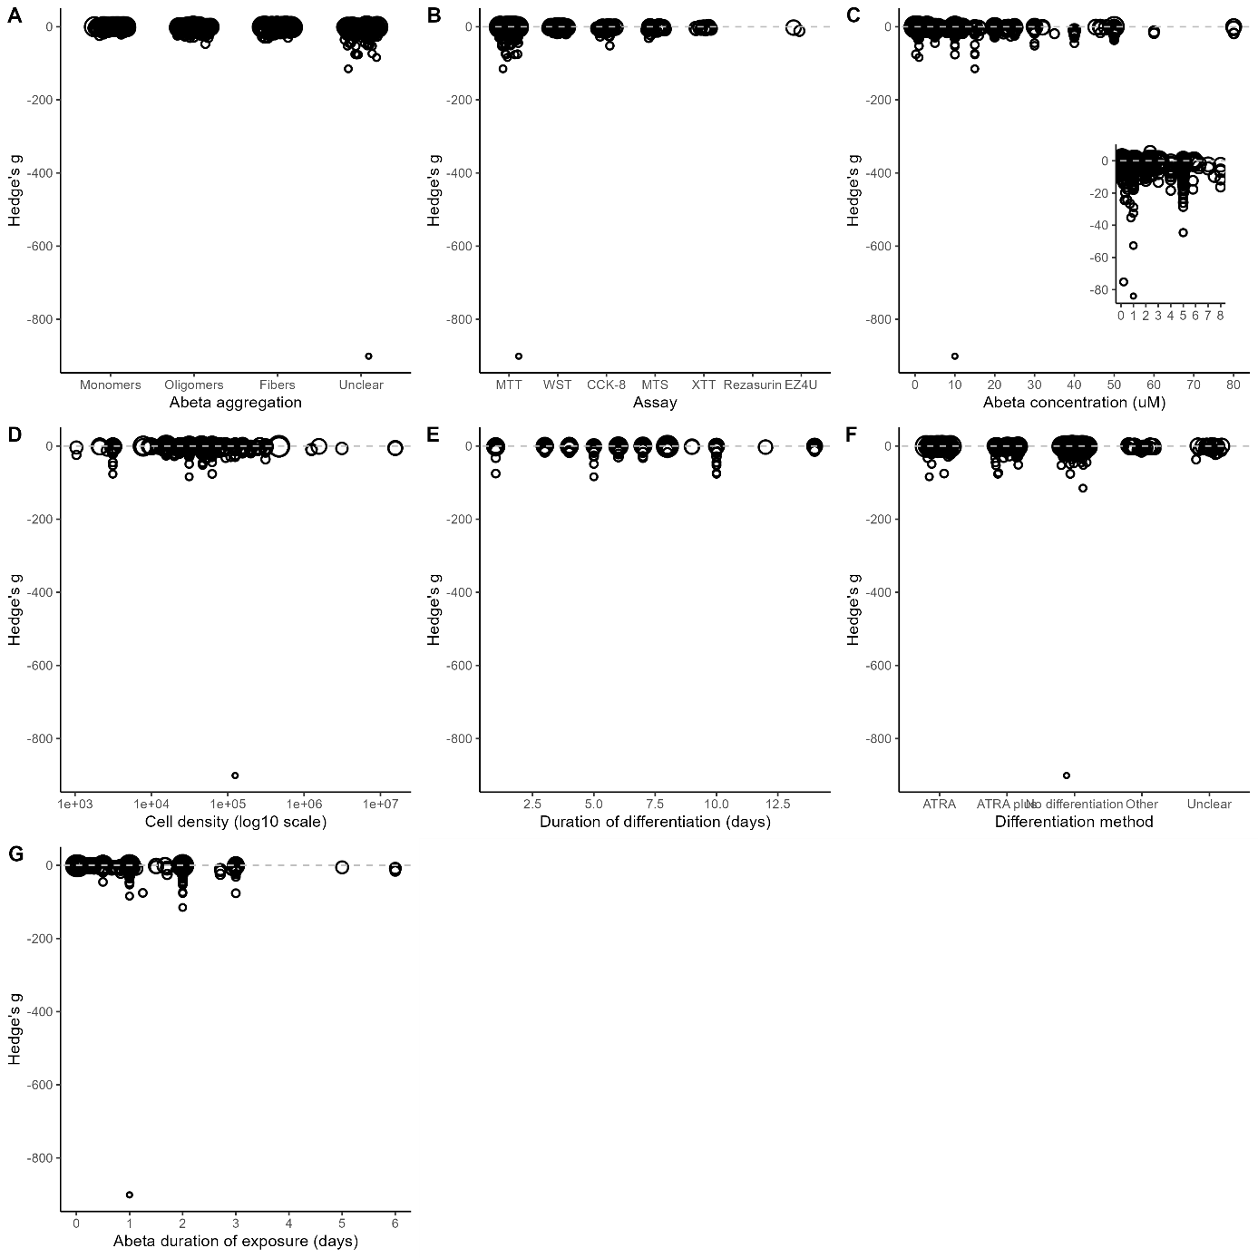

Figure 5 – Univariate meta-regressions. Each experiment is represented by an open circle, with size corresponding to the inverse variance (smaller circles are more precise). In panel C, the inset shows only the experiments with concentration below 10 uM.

Meta-regressions (multivariate)

While univariate meta-regressions are informative, they can be confounded by the covariation of certain variables. To account for this possibility, we ran multivariate meta-regressions.

To be included in the multivariate meta-regression, each experiment must have all variables reported – this criteria led to the exclusion of 1114 experiments, leaving 86 to be included in this analysis. As it is larger than 10 times the number of variables selected (7, as defined in the study protocol), we test all 128 possible models with the combination of all variables. Table 17 shows the best two models selected by the corrected Akaike Information Criteria (AICc).

Table 17 - Three-level multivariate meta-regression models for testing selected protocol variables, considering nesting of experiments within articles. The complete list of covariates tested is: method of differentiation, duration of differentiation, state of aggregation, concentration of Aβ, duration of exposure to Aβ, assay, and cell density. Out of 128 tested models, we present the best two as selected by AICc. Grey lines contain sample sizes, AICc, Akaike weights, intercept effect sizes as absolute mean differences, p-values and I2 for the model, as well as R2 values and Q-test p-values for the full range of moderators. White lines contain betas indicating the additional contribution of each unit/category to the effect size (as well as sample sizes and p-values for individual variables). Reference category in the intercept is systemic injection.

|  |  |  |  |  |  |  |  |  |
| --- | --- | --- | --- | --- | --- | --- | --- | --- |
| **Model and categories** | **Sample size** | **AICc** | **Weight** | **Effect size [95% C.I.]** | **p-value** | **I2** | **R2** | **Moderator p-value** |
| Concentration of Aβ + Duration of Aβ exposure | 86 | 565.6 | 0.37 | -0.12  [-3.1, 2.9] | 0.935 | 95.4% | 0% | <0.0001 |
| (µM) |  |  |  | -0.13  [-0.2, -0.07] | <0.0001 |  |  |  |
| (hour) |  |  |  | -0.10  [-0.1, -0.06] | <0.0001 |  |  |  |
| Concentration of Aβ + Duration of Aβ exposure + Cell density | 86 | 567.4 | 0.15 | -1.19  [-4.2, 1.8] | 0.429 | 95.3% | 0% | 2.2x10-9 |
| (µM) |  |  |  | -0.04  [-0.05, -0.02] | 2.3x10-7 |  |  |  |
| (hour) |  |  |  | -0.10  [-0.15, -0.05] | 7.8x10-5 |  |  |  |
| (unit) |  |  |  | 2.8x10-6  [-4.6x10-6, 1.0x10-5] | 0.463 |  |  |  |